**Homework 4 Setting up a Jupyter Notebooks Container**

Now it gets exciting. We are going to use our container knowledge to install a Jupyter Notebooks container. We are just going to install a very basic container and run a couple simple snippets of code.

1. Setting up our Jupyter container.
   1. You will need to get to the command line to download the image of Jupyter Notebooks. You can do this in powershell or commandline both seachable in Windows. Similar in MAC just get to the command line. Then you will just want to run a docker command to download the image we are going to use. This is where it gets interesting because you can see all the images available and the specific uses. In the screenshot, I am searching hub.docker.com for an image for us to use.

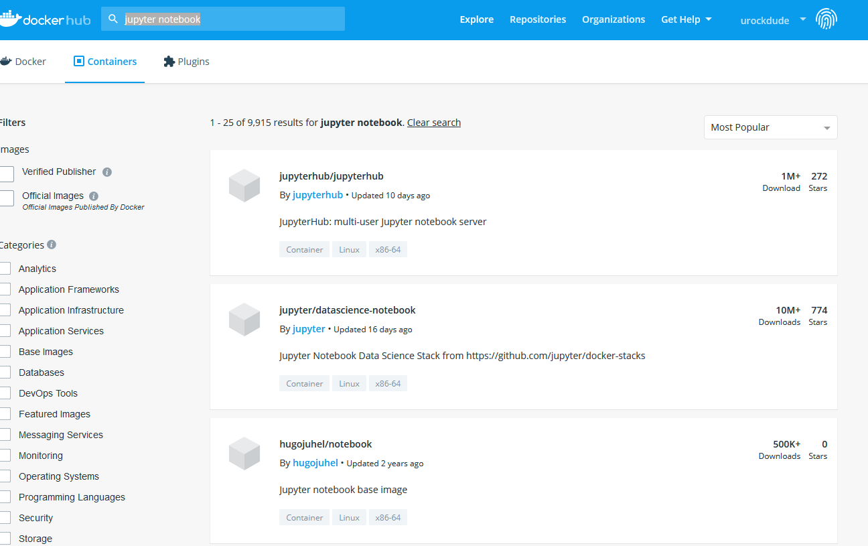

Lets go ahead and use jupyter/datascience-notebook.

In your command line enter:

docker pull jupyter/datascience-notebook

(You can check out this image in your Docker Desktop under images.)

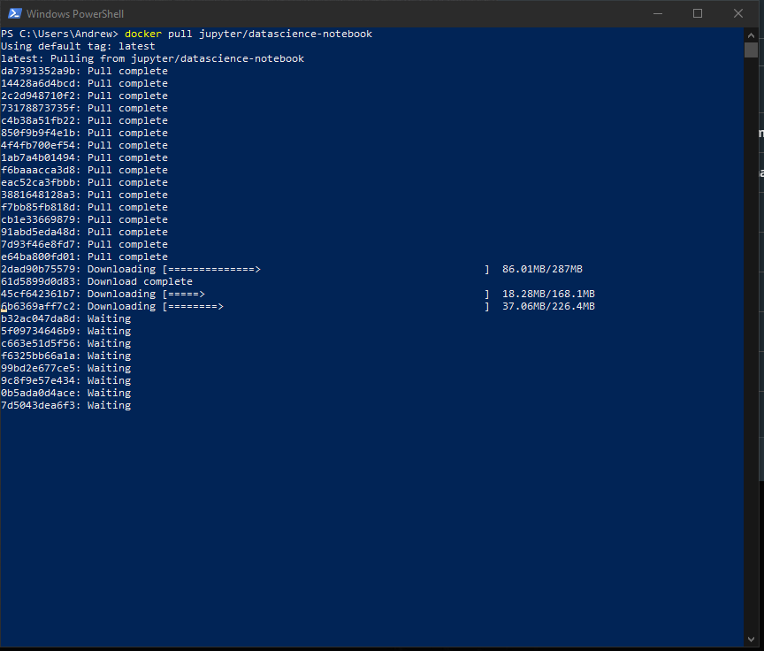

1. Now let’s create a container running Jupyter Notebooks that we can work in.

docker run –p 8888:8888 jupyter/datascience-notebook:latest

(If this command doesn’t work look in the appendix for another option)

Your going to notice the kernel start up in the command line.

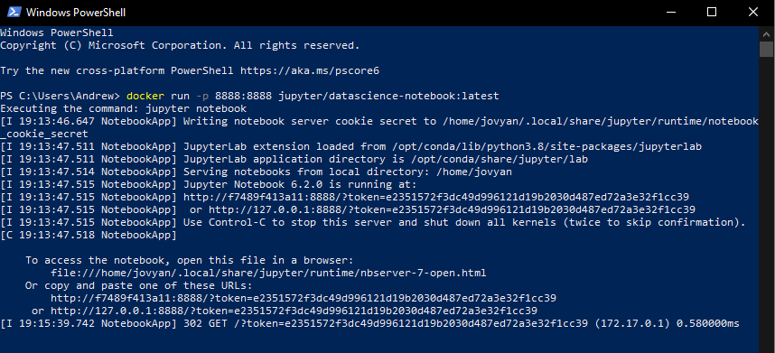 Just copy the bottom url with 127.0.0.1…..to open up your notebook.

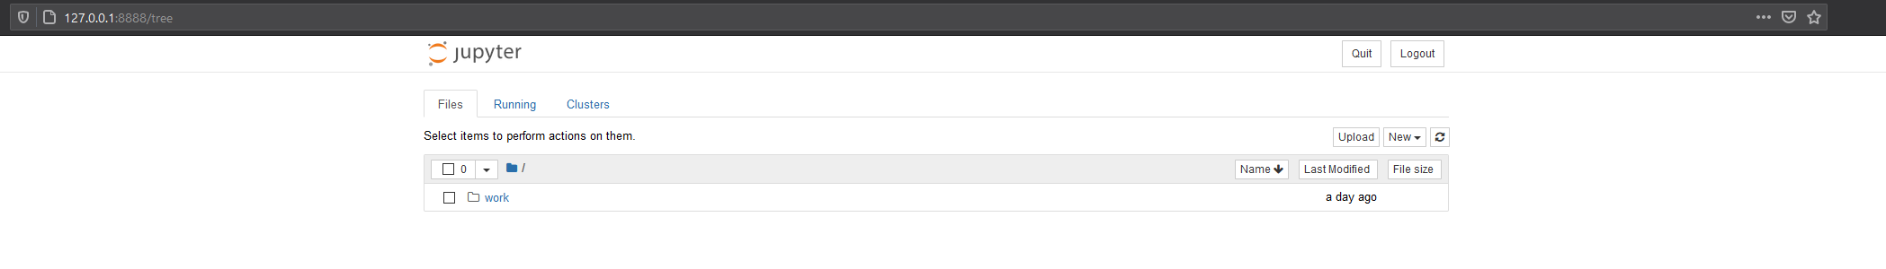

1. Now let’s just run a few simple commands in a Jupyter Notebook.

Go ahead and click on “New” in the menu and select Python 3 to setup your python notebook.

This will create your notebook and your ready to put in a simple program.

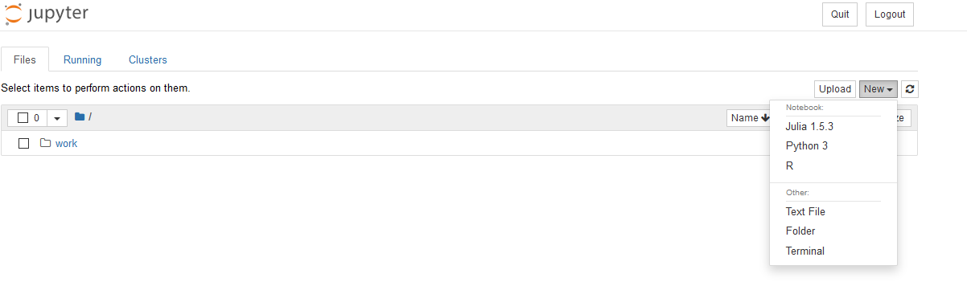

1. Now just run a simple program. For example go back and use the examples from the video in homework 3. Here are some examples of code that you could work with as well.

print(“hello world”)

# this will run a standard output of whatever you put in quotes

# this is a standard function in python

# a function is a piece of code written to execute additional code that is commonly used (so you don’t have to write it over and over)

a=2

# creates an ‘a’ variable to hold an integer

b=3

# creates a ‘b’ variable to hold an integer

a+b

#adds the values in the variables together

Def plus(a,b):

a+b

# creates a function called plus to add together two integers

plus (5,6)

# how to run your function with two integers of your choice

1. Take a screen shot of your desktop and Jupyter Notebooks to show that you have gotten it all working. Also include a screen shot of your program.

**Appendix**

If you using the docker desktop app, it is possible to just start the server from inside the app.

1. Open the desktop app and navigate to the image.
2. Put your mouse over the image name and you will notice commands pop up on the right side.
3. Move over and click “Run”
4. **Important** – Make sure that you click on the options and add “8888” inside the Ports, Local Host prompt.

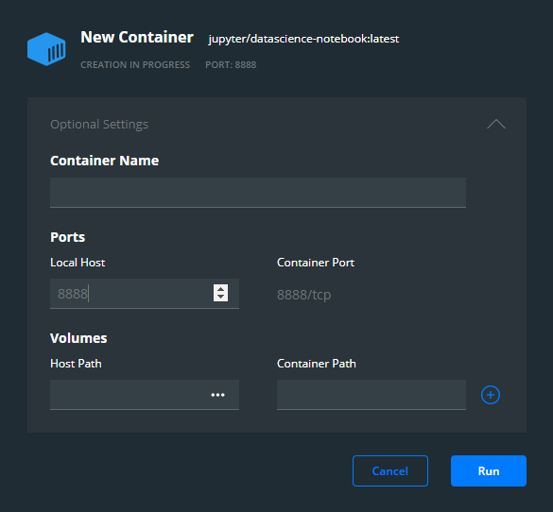

1. Now click run to create the container.
2. Lastly, you will need to double click on the container to get the command line of the container to display on the screen. This is where you will need to look to find the 127…. url to log in to Jupyter Notebooks.
3. Go back to step 2 above to finish logging in to Jupyter Notebooks with the url.